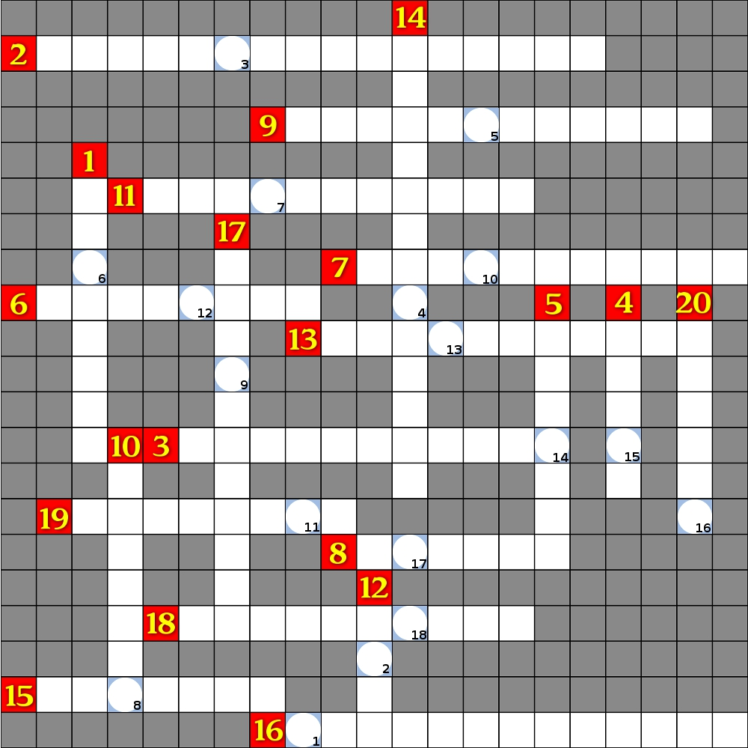
Horizontal

2: Despite running around for hours already, Lara still shows no sign of being exhausted while exploring this Peruvian valley. What's the full name of the levelset? (3 words)

3: I'm sure you know which level is depicted here (it's not like you one could forget this nice view!) and so I'm sure I'm not giving away too much, if I tell you, that it's just one part of a series of levels. What's the name of its successor? (2 words)

6: What's the name of the film this level is about?

7: The creator of this levelset seems to love Nightwish and especially did a great job in terms of mixing visuals with the songtext of "Scaretales" when creating this cutscene, which introduces the final fight. What's the name of the level? (2 words)

8: Rome wasn't built in a day – and so this levelset has already been worked on for ages. We do know however, that it's going to be something huge, thanks to the great demo. What's the nickname of the author?
9: The depicted level got created for a special annual event hosted by a TR-fansite and so far the author built two levels for this event. What's the name of the other one? (2 words)

11: One of the classics! Which country is the author from according to their profile on trle.net?

13: What's the name of the little creature, that stands in the left corner of the screen, just next to Lara? (2 words)

15: Fill the last name of the person who built this highly successful custom in the blanks.

16: In this cutscene Lara retrieves a map from a skeleton. In which level (NOT game – everyone should know this one ^^) does it play? (4 words)

18: This marshy landscape just screams "Voodoo", but before Lara arrives there in the game, she has to explore a city. Which one? (2 words)

19: Which borough is Lara walking through in this screen?

Vertical:

1: Only one of numerous amazing moments in this top-notch-custom. What's the last name of the builder?

4: This level not only has loads of eye-candy but also comes with a nice story-line, including NPC's. One of them, who seems to be a barmaid even helps you at some points. What's her name?

5: The author, whose last name has to be filled in the blanks has built 3 whole level series and thus provided us with numerous hours of pure gaming-fun.

10: One of the authors of this levelset also built the great outfit in the picture, which is placed in an object-show-off area in the game. What's this author's nickname?

12: The passion for detail, that's present in this imaginative custom level is admiring. What's the nickname of its author?

14: A whole level in this game is named after this magnificent church, which actually really exists. What's its name in the language of the country? (2 words)

17: As you can see it's not Lara who is the main character in this game, but a great looking Manga-creature. What's its name according to the author, who introduces it at the beginning of the level (Starring: .......) (2 words)

20: The picture shows one of countless loading screens in this huge custom. Which country is its author from, according to their profile on trle.net?

